# Problem 3 - Magic Cards

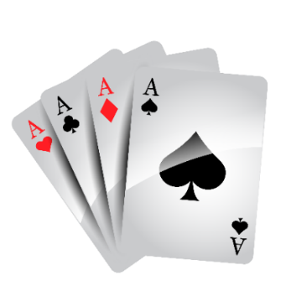

Create a program that **adds**, **inserts**, **removes,** and **swaps** cards in a **new deck**. On the first line, you will receive all cards in the original deck, **separated** by "**:**".Until you receive the **"Ready"** command, you will get commands in the format:

* **"Add {cardName}"**:
  + If the card **exists** in the **original deck**, add the card to the **end** of the **new** **deck.**
  + Otherwise, print **"Card not found."**
* **"Insert {cardName} {index}"**:
  + If the card **exists** in the **original deck** and the **index (in the new deck) is valid**, insert the card at the **given** index of the **new** **deck.**
  + If the card **does not exist** in the original deck or the **index (in the new deck) is invalid**, print **"Error!"**
* **"Remove {cardName}"**:
  + If the card **exists** in the new deck, remove it.
  + Otherwise, print **"Card not found."**
* **"Swap {cardName1} {cardName2}"**:
  + **Swap** the **positions** of the cards in the new deck.
  + Input will **always be valid.**
* **"Shuffle deck"**:
  + **Reverse** the **new** **deck.**

When you receive the "**Ready"** command, print the cards in the new deck, **separated by a single space**.

### Input / Constraints

* **On the first line,** you will receive the arsenal of all cards available separated by **":"**.
* **On the following lines,** until you receive the **"Ready" command**,you will receive commands to arrange your deck.
* **An index is valid when it is non-negative and less than the size of the collection.**

### Output

* Print the cards in your deck on a single line, separated by a single space.

### Examples

|  |  |
| --- | --- |
| **Input** | **Output** |
| Innervate:Moonfire:Pounce:Claw:Wrath:Bite  Add Moonfire  Add Bite  Insert Claw 0  Swap Claw Moonfire  Remove Bite  Ready | Moonfire Claw |
| Timetwister:CopyArtifact:Lifeweaver:TimeWalk  Add UndergroundSea  Add Timetwister  Remove Wrath  Add CopyArtifact  Shuffle deck  Ready | Card not found.  Card not found.  CopyArtifact Timetwister |
| BlackLotus:Bite:Innervate:Moonfire:CopyArtifact  Add BlackLotus  Insert Claw 1  Add Moonfire  Add Bite  Ready | Error!  BlackLotus Moonfire Bite |